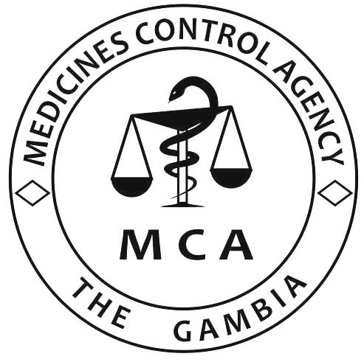

MEDICINES CONTROL AGENCY
Kairaba Avenue, K.S.M.D. Pipeline, The Gambia. Telephone: (+220)4380632, www.mca.gm
Application for Licensing as Importer of
Medicines and Related Products
New licence Renewal Licence No.
PARTICULARS OF APPLICANT
Name of Entity
Location (Physical Address)
Contact Details | Telephone No.  Email  Website
For new Licences only
Date of Incorporation of Company
Business Registration number

ITEMS TO BE IMPORTED (Tick all as appropriate)
For Human use For Veterinary use
Medicines
Allopathic Herbal Homeopathic Biological
Nutritional Supplement
Other products
Cosmetics Medical Device Diagnostics
Other (please specify)
Attach the required documents
DECLARATION
We, the undersigned, hereby declare that all information contained herein is correct and true.
Name of Supervising Pharmacist |  | Registration Number of Pharmacy Council
Signature |  | OFFICIAL STAMP
Date
Name of Head/Owner of Entity

Signature
Date

